**A Multi-factor Security Protocol for Wireless**

**Payment-Secure Web Authentication using Mobile**

**Devices**

Challa Venkata Pranith [1], Valiveti Lohya Sujith [2] , Kolli Sai Kiran [3] , Pulivarthi Goutham [4],

1,2,3,4 *Koneru Lakshmaiah Education Foundation (Deemed to be University) , India*

**Abstract:**

The way we live has been reformed by SmartPhones. Cell phones and  PDAs have been packed with ubiquity to a great extent and consumers have  now started webbased banking, webbased item purchasing and other online administrations Either the site or the remote flexible channel has been used autonomously by previous web access authentication systems to confirm the personality of faroff clients. To get to the latest online administrations reliably needs a username and secret phrase to verify the client personality. This is a major weakness because the hidden word can be compromised and later used by the man in the center attack to make illegal entry to the record of the client. We are likely to make a validation system based on a multi-faceted verification method that is both reliable and deeply accessible. It features a proprietary way to deal with rendering a validation system based on spasms (Exchange Recognizable proof code) and SMS (Short Message Administration) in order to enable the conventional Login/secret phrase framework to get an additional security level. In this paper we are proposing a new system and a protocol for Secure way of transactions by using Multifactor Authentication System

**Keywords:**

TIC (transaction identification code), Multifactor, Online transaction/payments, Authentication

1. Introduction:

As registering become imminent, individuals are progressively relying on the Internet to use their enterprise over the Internet. The Web is generally a preferable choice for online services such as internet enterprise, e-casting a ballot, e-banking e-government, and soon something close to that... Online applications need a defensive tackle highlight to ensure confidential customer information. Multifactor Authentication makes more and shifted dividers to shut out some unacceptable individuals from seeing your data

* 1. Types of Authentication Systems:

Authentication Using a Single Factor (SFA):

Figure 1: SF-Authentication

The most straightforward sort of confirmation strategy is single-factor authentication. A individual matches one credential with the SFA to verify himself or herself online. A password to a username will be the best known example of this. Today, most verification utilizes this kind of verification methodology.

Problems with Single Factor Authentication:

* Vulnerability problems
* The lacking of a backup stronger authentication
* The login credentials need to be strong enough
* We should not login in multiple devices as we cannot secure them.

Authentication Using Two factors (2FA):

Figure 2: TF-Authentication

Two-factor-Authentication is a combination of single-factor-authentication and a other factor of authentication, such as a mobile device, using only something he or she owns. Getting straight: utilizing 2 factors to validate an identity

Problems with Two Factor Authentication:

* Phishing Attempts
* Social Engineering & Brute-Force Attacks
* Broken Logic
* Key Logging

Authentication Using Multiple Factors (MFA):

Figure 3: MF-Authentication

This is basically the next level security authentication system where we can authenticate the user or verify the user in multiple factors of security in-order to achieve enhanced security system

2 Literature Survey:

In 2016, Ashok Nath[1] faced problems and difficulties in the two-factor authentication method as the "store-front" looks genuine, and the user ends up entering directly into the hands of an identify information which are very much to be secured i.e not to be exposed to the outside world other than our-self. Coming into other type of security violation is if the would-be hacker already has access to the device itself. Then the intruder tries to piggyback the transmission and either execute fraudulent transactions or access protected transactions when the user accesses either company or internet services.

Kumar Abhishek and Prabhat Kumar[2] published a study on multifactor authentication systems in 2017 as new Authentication challenges and opportunities ensure that a customer is who they claim to be. As the authentication process includes more considerations, the appreciation of authenticity increases exponentially.

In 2017, Rajeev Ranjan[1] given the preferred use and interpretation of multifactor authentication that current systems can use. It is referred to as Strong Authentication or Multifactor Authentication when the protection infrastructure uses two or more separate and different forms of authentication mechanisms to protect the well-being of legitimate Multifactor authentication uses combinations of anything to provide more remote authentication than usual, weak single-factor username and password ' In 2018, Aleksander Ometov, Sergey Bezzateev, Sergey Andreev[3] proposed the challenges faced by MFA management as the identification of users is a key element for a cautious and systematic approach to the adoption and implementation of MFA solutions, where most problems arise from opportunities and potential problems.

**3 Existing Protocol / System:**

Protection is an important factor in the online payment system focused on the web. There are numerous network vulnerabilities affecting web protection arrangements and growing electronic sharing hazards. The majority and first authentication process is nothing but password credentials, So we feel that this type of Authentication/Verification framework doesn't really verify or validate the character of the customers that the person in question claims to consistently meet the current electronic administrations requires a username and secret key are done to verify the character of the client. In regard to communications, classified information protection has consistently been an important issue. With equipment advancements that give customers the advantage of transparency used in mobile phones, individuals are currently investing more and more energy in these gadgets. In addition, with the viral popularity of web-based media applications and single sign-on, customers generally do not escape varying potential risks with their data

The current m-payment schemes can be categorized into three key groups, as discussed in

- Payment mechanisms focused on accounts,

- Payment system for mobile POS,

-E-cash or E-wallets.

Therefore in order to improve more and more reliable protection for online payments, we have proposed a new multi-factor authentication protocol.

Currently we have multiple factor authentication system in some of the online systems , but here the issue is with the Non MF-Authentication system for which we cannot have a next factor to authenticate or to verify the user or client so in place of that physical factor authentication system or to enhance the current system we are here with TIC (Transaction Identification Code) based Authentication system which will act as a MF-Authentication System

**4 Designed System:**

For high-hazard exchanges that expect admittance to customer data or the exchange of assets to different gatherings, single-factor authentication is deficient. Multi factor authentication methods need to be used for securing online transactions We use multiple factors to authentication in our scheme of design, using two different modes. TIC and SMS are used to execute the execution. Although in previous approaches to the issue, SMS was used. We are incorporating the latest definition of TIC is the designed method of authenticating a online transaction & user to previous approaches to the problem. TIC codes are used to authenticate the client or user treating as a Next level Perception to authenticate the user/client

Codes for TICs are:

*Disseminated to the consumer by a banking institution.

*8 bits of Randomly Provoked Codes are accredited to the client/user.

*Sophisticated sequences of digits or combinations of binary or mixture of numbers, characters, special symbols may be feasible.

*The generated TIC will be used for a single transaction itself

4.1 Protocol:

Here the below Screenshot is the sample execution of our proposed TIC based Multifactor-Authentication as a java Enterprise Application And Our proposed or Designed protocol is segregated into parts of flow for execution, which is mentioned below,

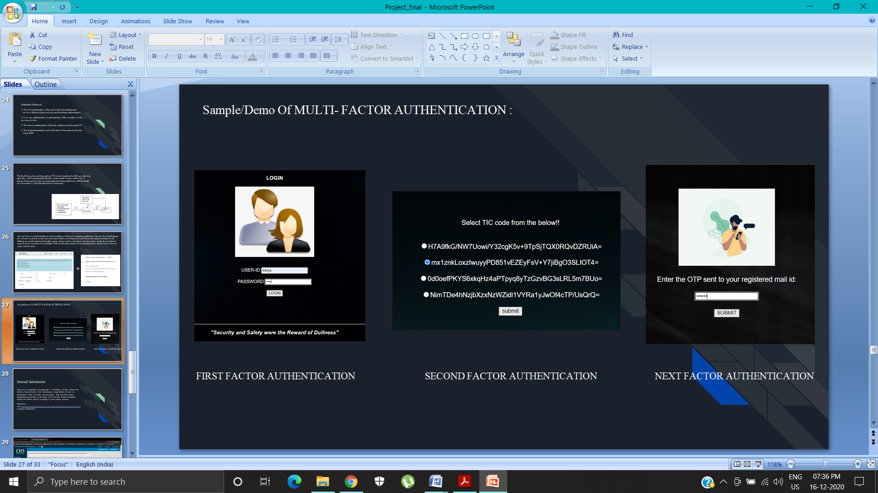

4.1.1 Protocol Workflow:

Figure 4: Designed Protocol for Multi-Factor Authentication

1. Initially the client will receive a list of tic’s along with the login credentials respectively from their banking institution. Each customer has only one login credential in Database record, anyway for each online trade, the tic code is uncommon. Customers can obtain a once-over of tic codes as demonstrated by their subtitles from the bank authority or affirmed money related establishment.
2. Basic authentication of a Web-based user-id/password is used to  validate the user in the Web Based Authentication Server.
3. A Bank Verification Worker can approve the username and secret key. The client will get a decision screen after client affirmation to continue to promote to the next step.
4. After successful logged in user will be prompted with a Greeting Quote. A session key is also produced by this phase.
5. So now here by the client/user has a choice of transactional modes i.e Two payment methods were considered: the system based on credit cards & the electronic transfer based on accounts. Adding other modes to our device is straightforward.
6. Here the user will enter the requisite particulars of payment related info,.
7. By basically selecting a tic’s from the dropdown of tic’s , the client can embed a tic codes code. Note that tic codes are put away with nearby encryption on the cell phone, with secret key assurance.
8. The worker for bank approval decodes the message got and extricates the tic codes. It at that point tests the tic codes got from the client by contrasting it and the tic codes list put away on the data set worker in the client account data. It drops the pre-owned tic codes from its information base if the two tic codes coordinate, and goes to the following stage. In the event that no tic codes co-ordinates those in the information base, the confirmation worker denies the exchange to the client and presentations a blunder message to the client.
9. The bank server creates a user recognition that allows the user to log out of the web portal free of charge
10. After the successful update for the ongoing transaction is completed, the authentication server will initiate the email to user to check the initiated web transaction.
11. Here now the at the user end through the smart gadget or PDA’s the user will prove himself by the a way of sms/email type of authentication.
12. The server will notify the user of the status of the transaction

Now Division/Segregation of the protocol into 4 parts which also include two-way authentication

**Part 1: User Authentication to the Banking Institute Authentication Server**

Figure 5: User Authentication to the Banking Institute Authentication Server

**Part II: Merchant Authentication to the Consumer**

Figure 6: Merchant Authentication to the Consumer

**Part III: User Authentication to the Banking Authentication Server**

Figure 7: User Authentication to the Banking Authentication Server

**Part IV: User Authentication by Email confirmation**

Figure 8: User Authentication by Email confirmation

**5 Security**

The attack of phishing has been a common vulnerability technique. Attacker’s tactically captures users' essential data of the user and carrying out the illicit transfer of funds. We consider different cases below to grasp the origin of the security.

*Case I: If attacker acquires login credentials:*

Confidential TIC codes issued to legitimate users and TIC’s are not available in public. For each online transaction, it is a one-time code and it is created randomly so attacker cannot guess the TIC

*Case II: Transmission of TICs over insecure channel:*

The transmission of TIC’s are done in encrypted format, so it cannot be easily decrypted by attackers to access private user information on the server side. In addition, only once is one TIC used and then discarded.

*Case III: If attacker acquires login credentials along with the one of the TIC codes:*

If the attacker receives a sample of TIC’s from any phishing technique, the attacker will not be able to crack the next coming or next to be generated TIC’s as it is a random generated TIC for each transaction

**6 Conclusion:**

The current validation protocol for online framework implementation is not to ensure that customers are safe from wholesale fraud, as the effect is that any aggressor gains entry into confidential customer data such as Master-card number or record secret key and allows illegal shop trade that will be charged to the record of the significant customerFor remote installation of the system, we zeroed in on an application-layer security response to conduct a start to finish verification and privacy of information between remote client and java-based protected worker. The introduced work suggested another web client validation convention focused on a multifaceted verification method that is fully safe and easy to execute.

Future work will focus on creating a modern and reliable way to produce TIC’s . Installing the TIC code on the mobile phone of the user must also be an The simple job is to discourage frequent customer visits to the banking institutions.

7 References

1. Article on security threats of mobile phones :http://news.zdnet.com/2100-1009_22-5602919.html.
2. Adi W, Mabrouk A., Al-Qayedi A., Zahro A. , “Combined Web/Mobile Authentication for Secure Web Access Control”, In the proceedings of the IEEE conference held on communications and Networking , pp. 677- 681, March 2004.
3. Dr. Winston Seah, Santhosh Pilakkat, Jaya Shankar P., Seng Kee Tan, Chin Siang Kee, Anindita Guha Roy, Edwin Ng., “The Future Mobile Payments Infrastructure A Common Platform for Secure M-Payments”, A Joint Study by Institute for Communications Research and Systems, December 2001
4. Asoke Nath, Tanushree Mondal , “Issues and Challenges in Two Factor Authentication Algorithms ”, In Proceedings of the International Journal of Latest Trends in Engineering and Technology , January 2016
5. Adi W., Mabrouk A., Al-Qayedi A., Zahro A. , “Combined Web/Mobile Authentication for Secure Web Access Control”, In Wireless communications and Networking conference,IEEE Communications Society, Atlanta, GA USA,volume 2, pp. 677- 681, March 2004
6. Qiong Pu, “An Improved Two-factor Authentication Protocol”, In Proceedings of 2010 Second International Conference on Multimedia and Information Technology, 24-25 April 2010.
7. Teppo Halonen, “A System for Secure Mobile Payment Transactions”, Supervisor: Professor Teemupekka Virtanen, Helsinki University of Technology, Department of Computer Science and Engineering, January 2002.
8. Ayu Tiwari, Sudip Sanyal, Ajith Abraham, Sugata Sanyal & Svein Knapskog, ”A Multi-factor Security Protocol for the Wireless Payment-Secure Web Authentication using Mobile Devices”, held on February 2007,IADIS International Conference, Applied Computing 2007, Salamanca, Spain, pp.
9. Sameer Saxena1 , Sonali Vyas2 , B. Suresh Kumar3 , Shaurya Gupta, ”Survey on Online Electronic Paymentss Security” In Proceedings of the 2019 Amity International Conference on Artificial Intelligence (AICAI), 4-6 Feb. 2019
10. J. Gao, J. Cai, K. Patel, and S. Shim , “Wireless Payment”, In Proceedings of the Second International Conference on Embedded Software and Systems (ICESS’05),Xian, China, pp